**EHAUSTIVE ANALYSIS OF INDIAN AGRICULTURE**

**POWER BI**

* **In this project we can learn about the power bi tools.**
* **Here we can download power bi tool from Microsoft.**
* **Now let us discuss the “ETL”.**
* **ETL stands on EXTRACT TRANSFORM LOAD.**
* **Extract means pull data from data source: csv, text, excel, database file.**
* **Transform means data processing, data cleaning.**
* **Load used for analysis.**
* **Analysis means keep facts, insights.**

**Let us start the project with basic tools.**

**Step1: Go to the Microsoft store and download the power bi.**



**STEP 2: Open the power bi app in desktop.**

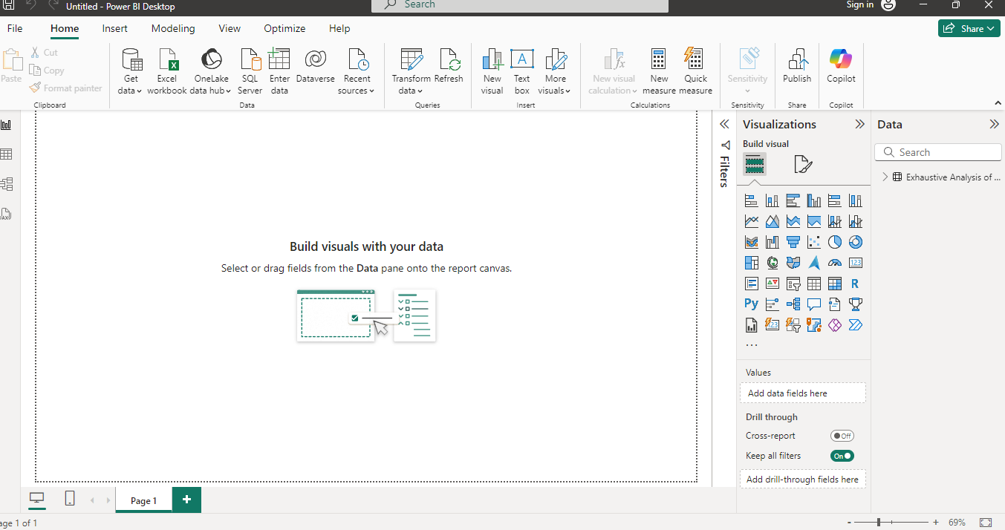

**STEP 3:Click on blank report and extract the data from the data source.** 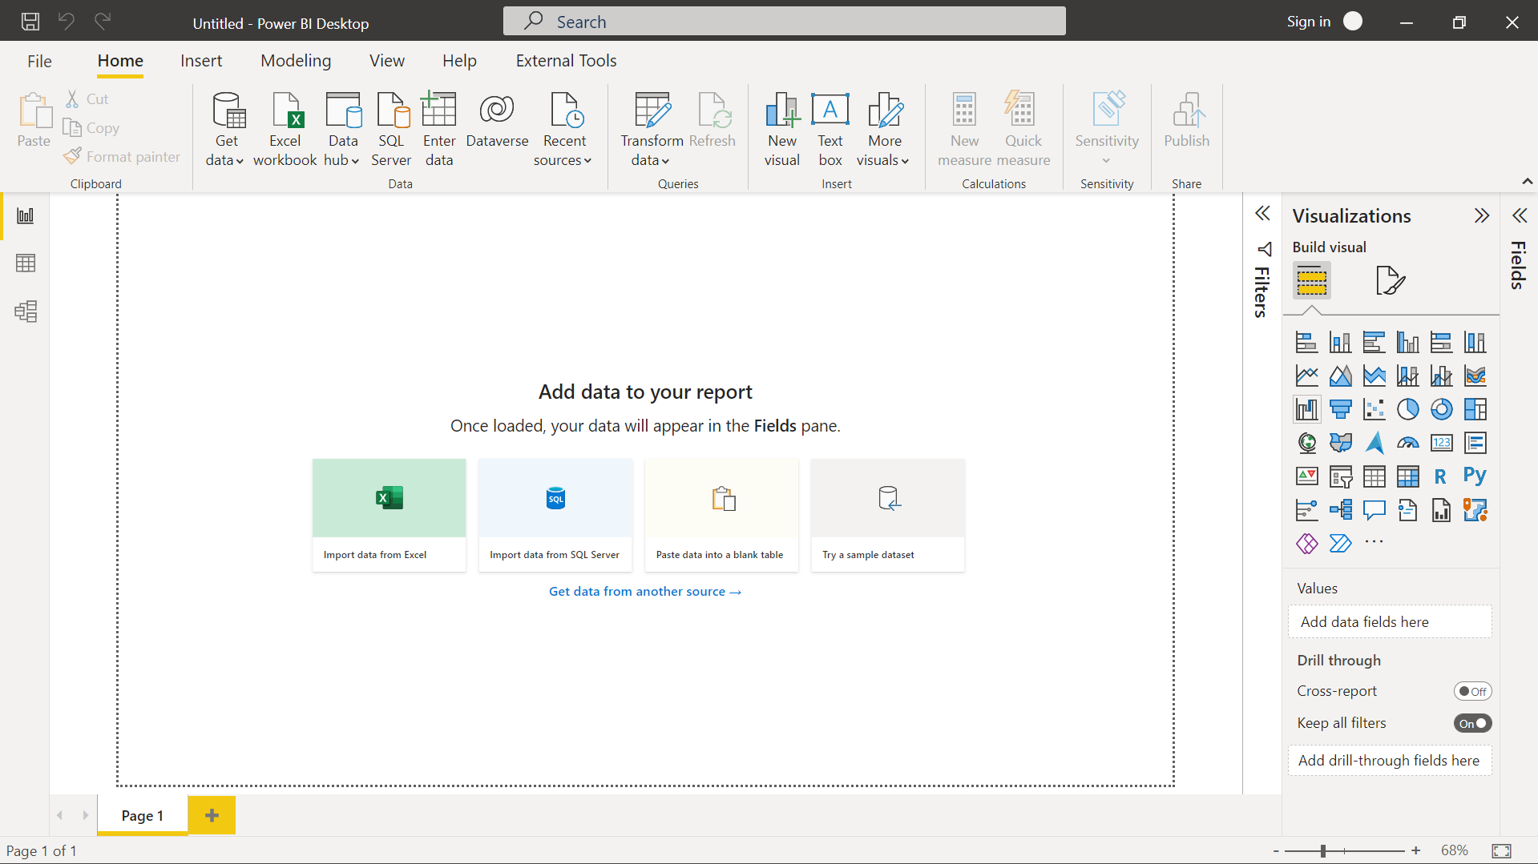

**STEP 4: Extract the data from the source.**

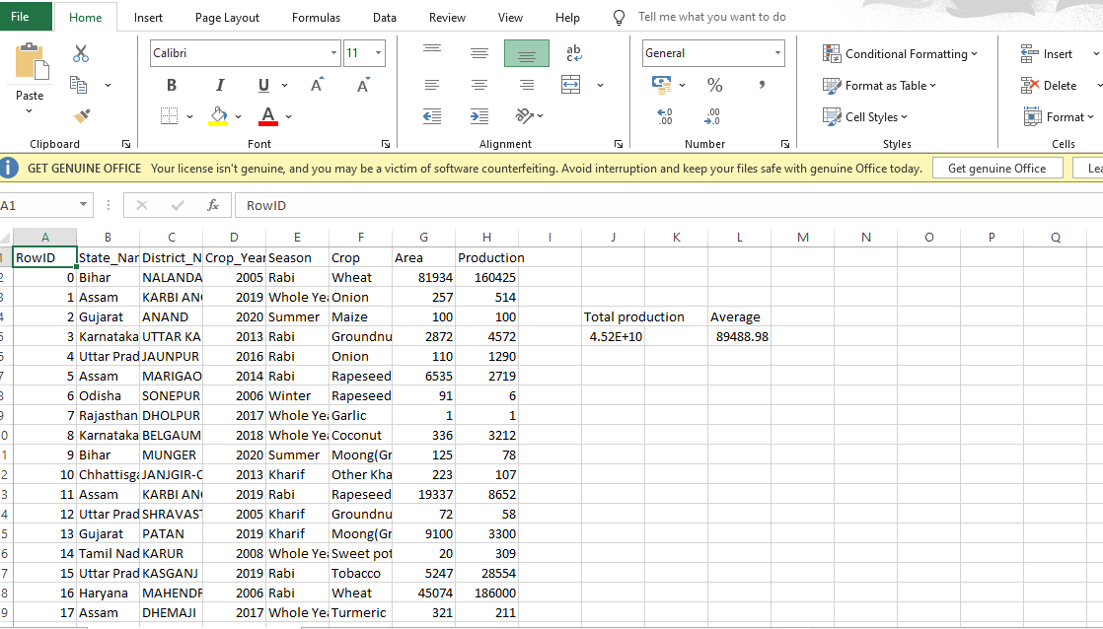

**STEP 5: We can click on load option then it completes the changes and we have three types of views are present. Report view, Table view and Model view. Let us observe the table view.**

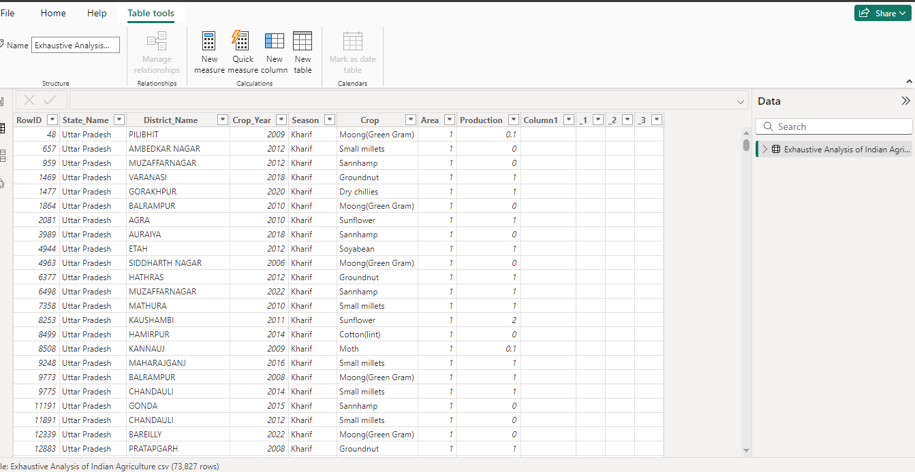

**STEP 6: Click on the transform data and we move the power bi editor. Where we can perform the empty rows and columns deletion and undo the operations back.**

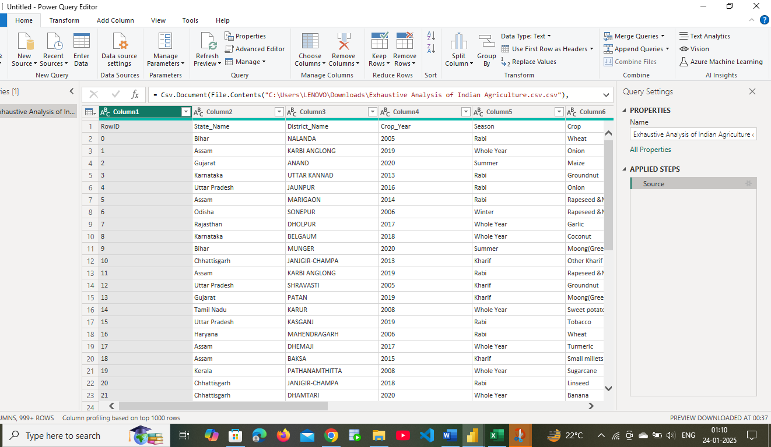

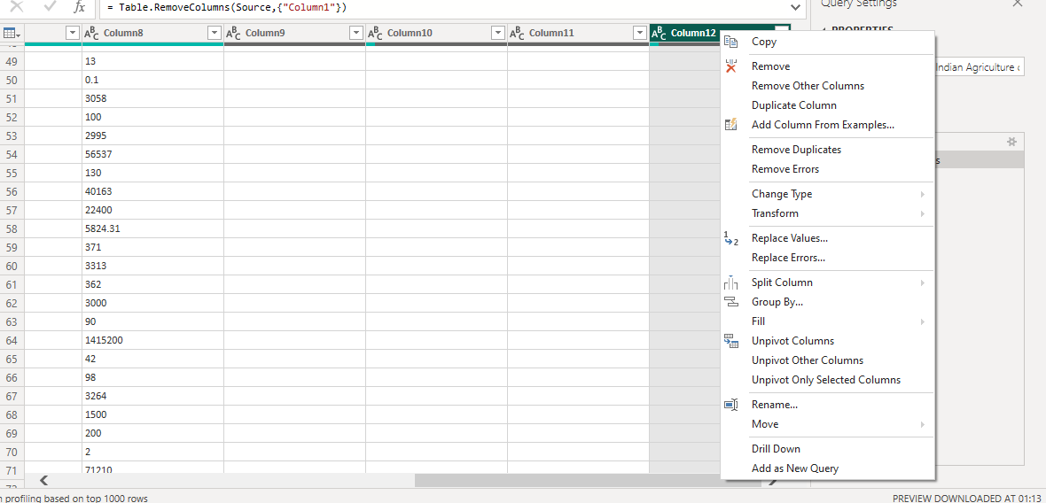

**STEP 7: By clicking on view button we can get any errors or empty will be checked we can delete it if we can find it.**

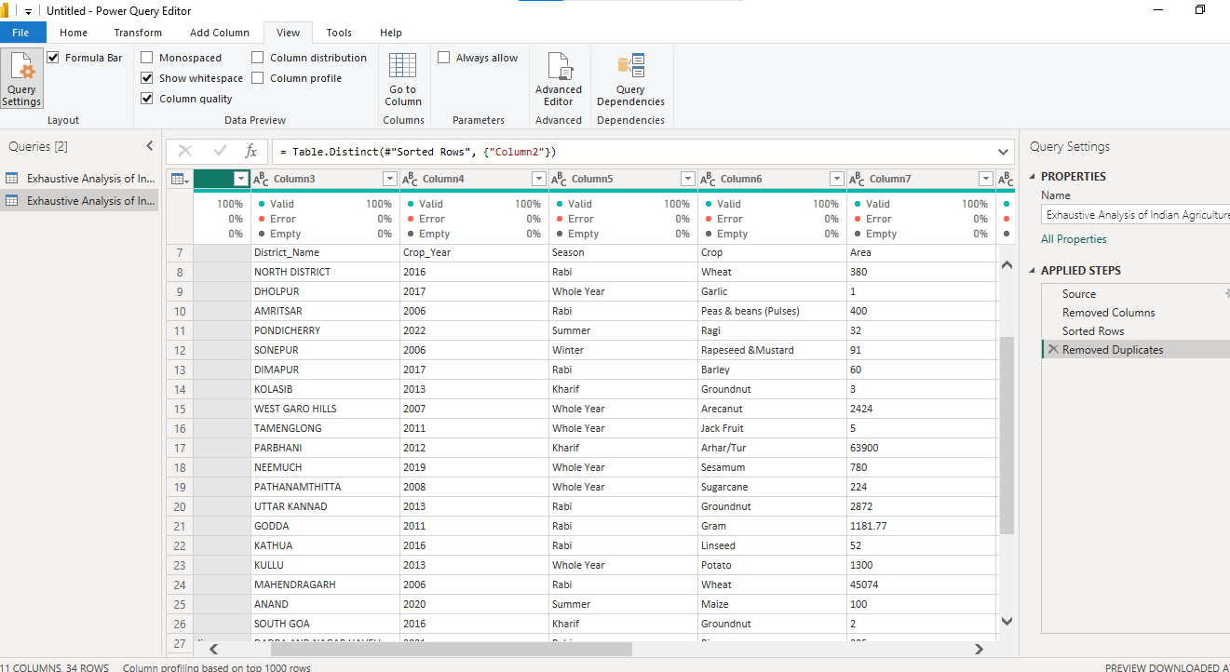

**STEP 8: We can change the data types in the power editor.**

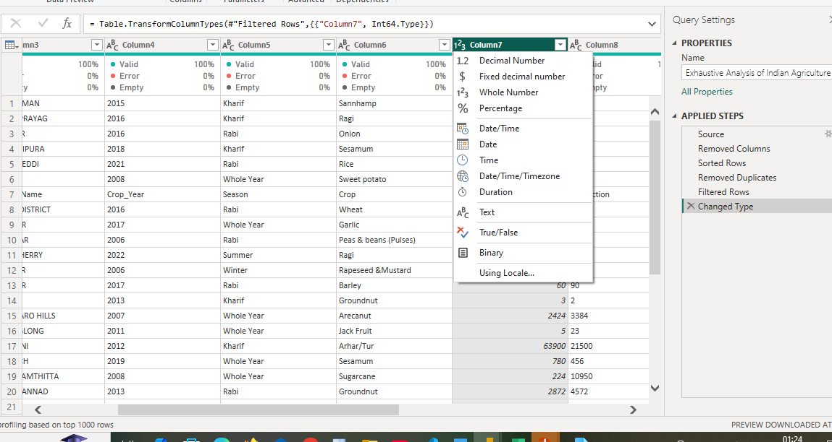

**So, these are the uses of power bi basic tools in the session.**